**JOBSHEET 1**



**Nama : Rama Pramudhita Bhaskara**

**NIM : 2241720128**

**Kelas : TI – 3H**

**Absen : 20**

**JURUSAN TEKNOLOGI INFORMASI**

**POLITEKNIK NEGERI MALANG**

**2024**

Instalasi Git:

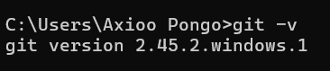

VSCode + plugin Flutter:

Flutter SDK:

Android SDK:

